

**FPT UNIVERSITY**

**USER GUIDE**

|  |  |
| --- | --- |
| **CLASS** | **SWD391** |
| **MEMBERS** | **Phạm Ngọc Duy (SE63523)**  **Đinh Đức Thuận (SE63010)**  **Trần Công Thanh (SE63219)** |

**Catalog**

1. **Foreword**
2. **Get the project**
3. **Feature and guide**
4. **Android**
5. **Login**
6. **Student**
   * **Navigate screen**
   * **Checking Attendance**
   * **Create a ticket**
   * **Review the ticket**
7. **Teacher**
   * **Navigate screen**
   * **Review the ticket**
   * **Change ticket status**
8. **Web**
   * **Login**
9. **Foreword**

This document is a tutorial for how to use the program on the computer and android device. There will be description on how to use the program.

1. **Feature and guide**
2. **Android**
   * 1. **Login**

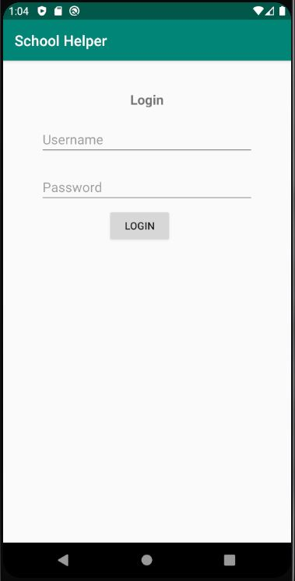

This is the first page of the program.

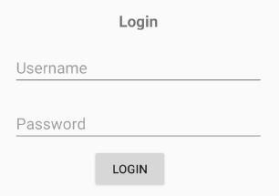

Fill the username and password field with your username to login into the app.

After you filling in username and password field, you click submit to login.

The app will not login when:

* Username or password is wrong.
* There is no internet connection.
* The server is offline.
  + 1. **Student**
       - **Navigate screen**

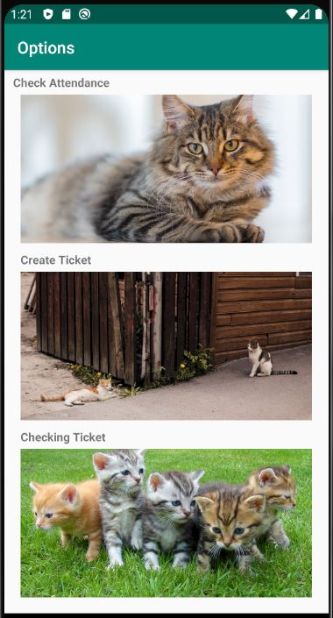

This is an option screen.

* + - * **Check attendance**



Click this picture to go to check attendance screen.

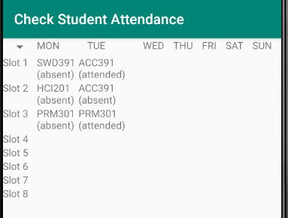

This screen will show your attendance status

* + - * **Create a ticket**



Click this picture to go to create a ticket screen

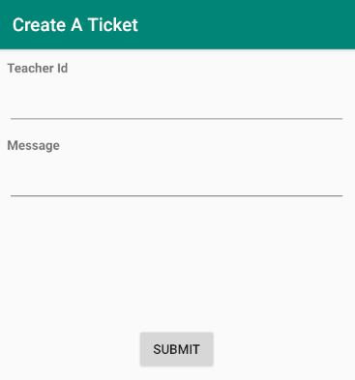

This is where you create your ticket

Fill in the id of your teacher into the teacher id

Fill in the problem you have into the Message field

After you have fill all the text then click the submit button to send the ticket to your teacher.

* + - * **Review the ticket**



Click this picture to go to tracking ticket screen

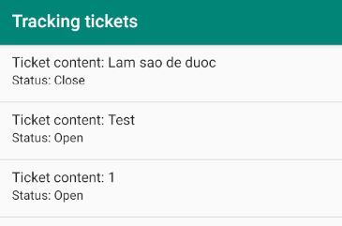

This screen will show you all the ticket you have and it status

* + 1. **Teacher** 
       - **Navigate screen**

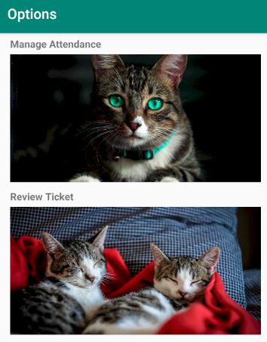

This is the teacher option screen

* + - * **Review the ticket**



Click this picture to navigate to review ticket screen

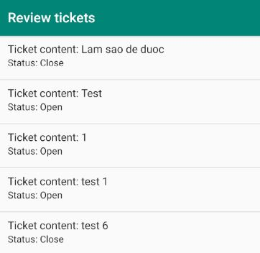

This is the teacher review tickets screen

Click into one of the ticket will send you to the screen to change ticket status

Ticket will be arrange in create date order

* + - * **Change ticket status**

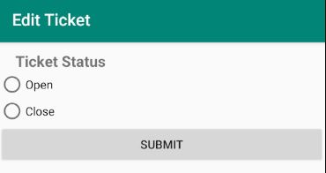

This is the change tickets status screen

Teacher can choose the open or close the ticket depended on the ticket is resolve or not

1. **WEB**
   1. **Login**

Enter website and click login to login page



Enter username and password for login. Account test

* + - Username: duypnse63523
    - Password: student

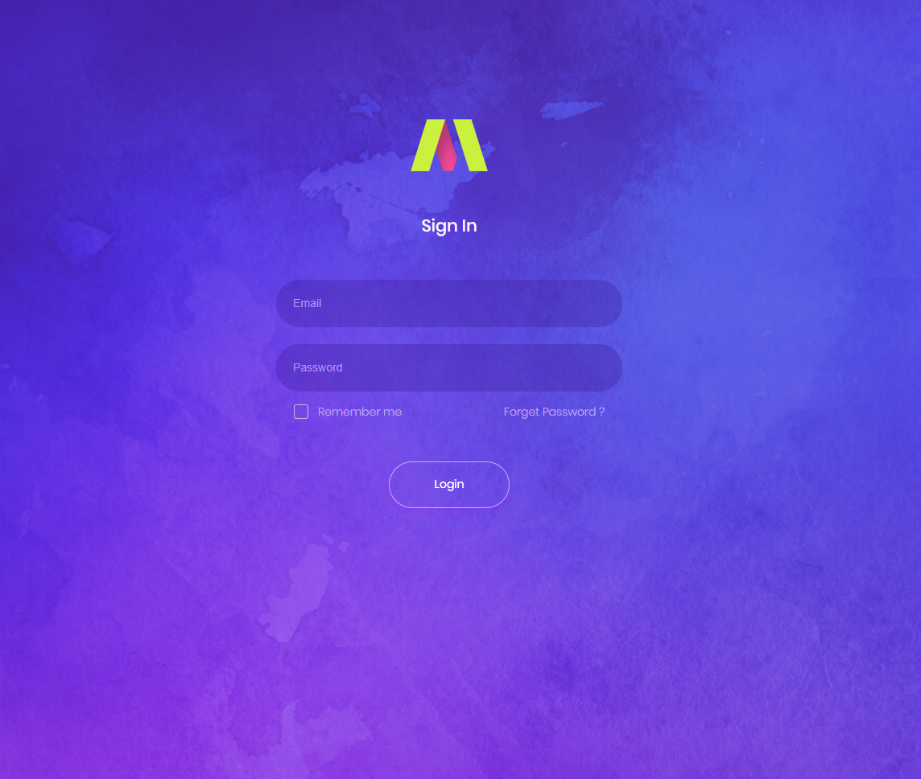

In Dashboard menu, click on attendance tab to check schedule.

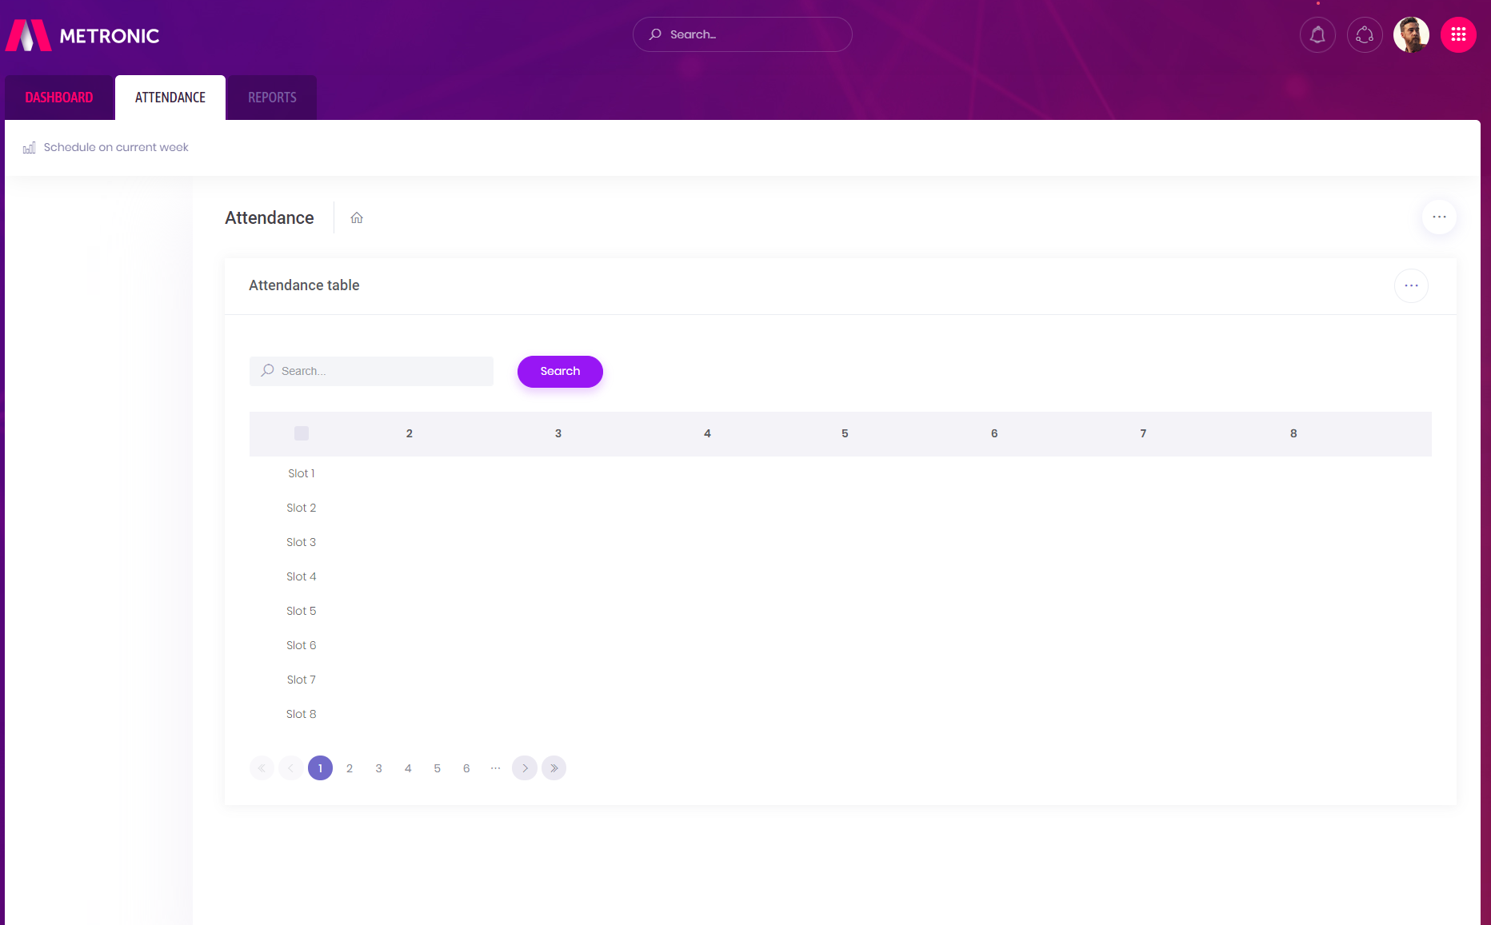

Search any week you like to get schedule on that week

